Q1.
Answer is B.

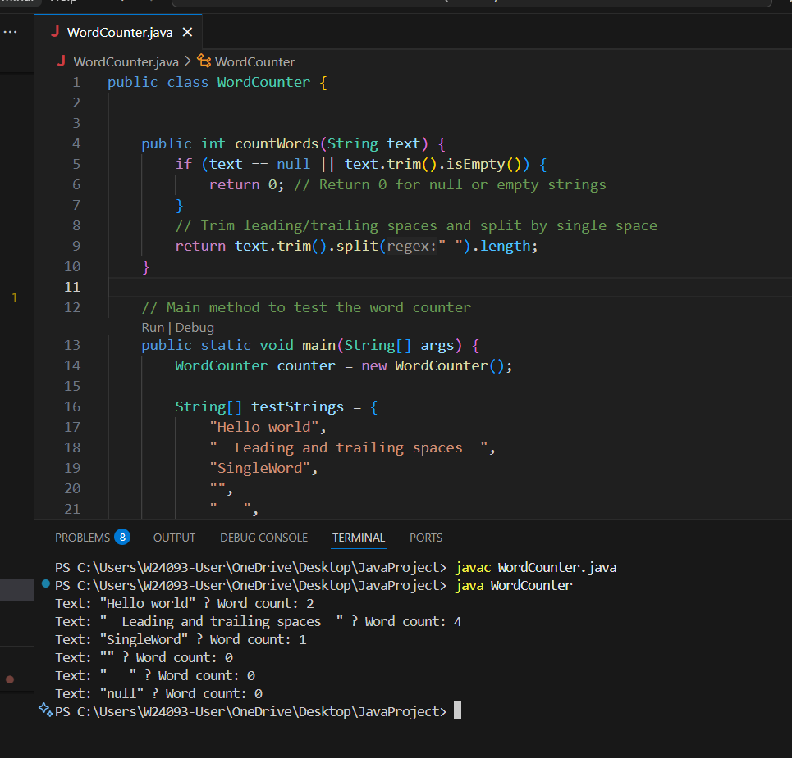

A: Incorrect in some cases.

B: Correct.

C: Incorrect. Arbitrary subtraction, under counts words.

D: Incorrect. Regex misused with split, gives wrong results.

Q2.
Answer is A and D.

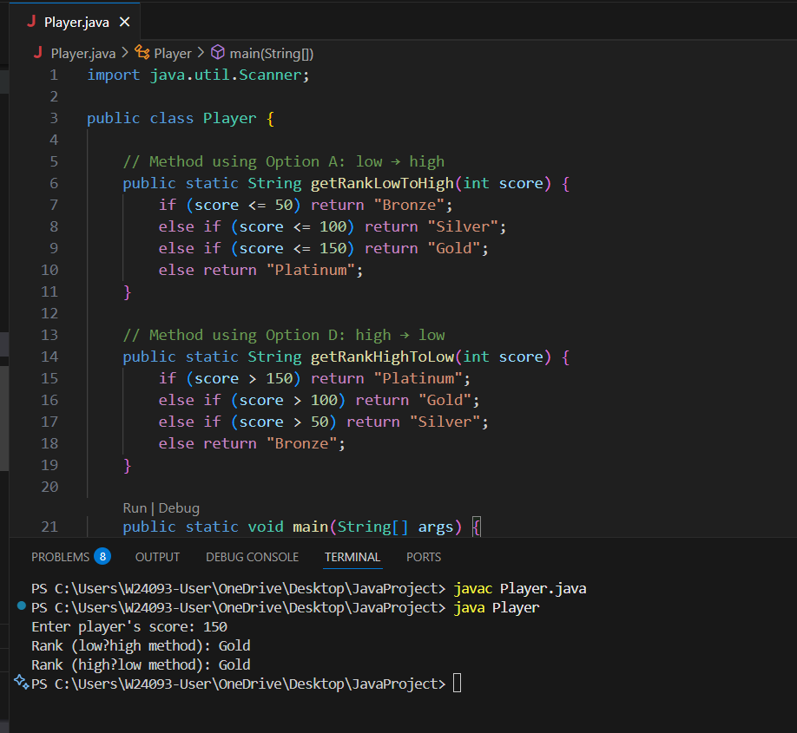

A: Checks ranges low→high, simple and clear.

B: switch cannot handle ranges in Java.

C: Infinite loop is unnecessary, less readable.

D: Checks ranges high→low, slightly better if high scores common.

Q3.
Answer is C.

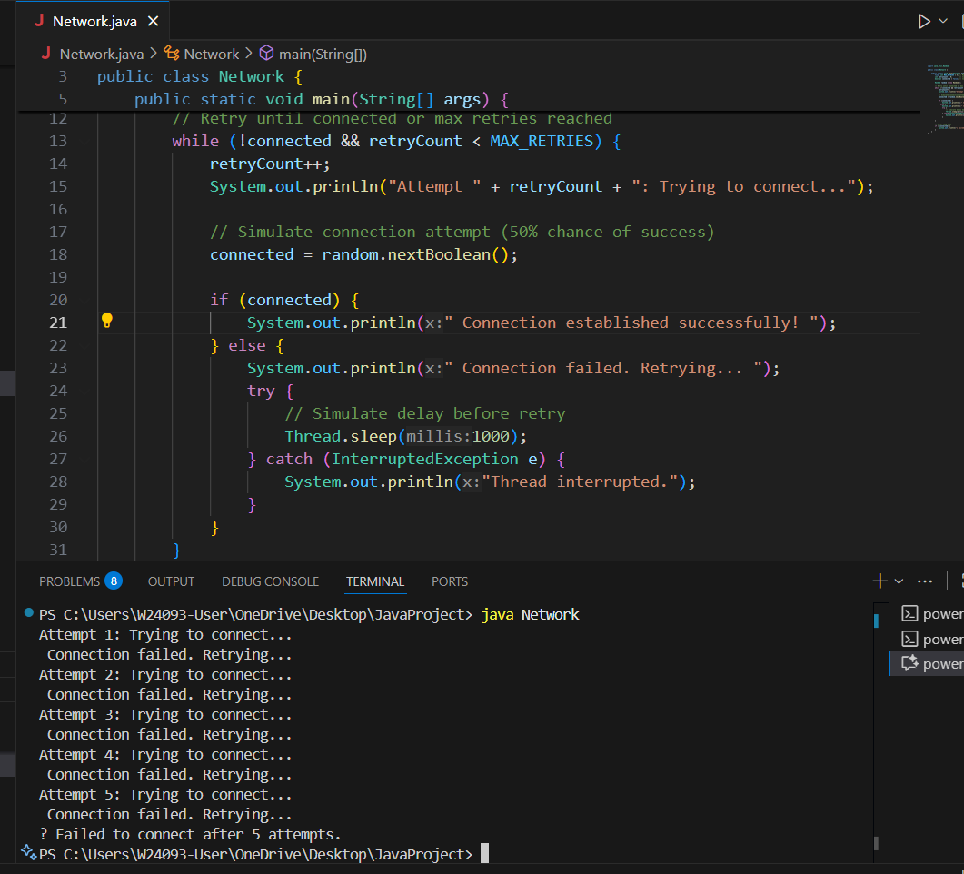

A: Used for one-time conditional checks, not for repetition.

B: Used for fixed value matching (e.g., menu options, constants).

C: repeating an operation until a condition is met,is exactly while loop.

D: Could technically work, but it’s less natural here.

Q4.
Answer is C.

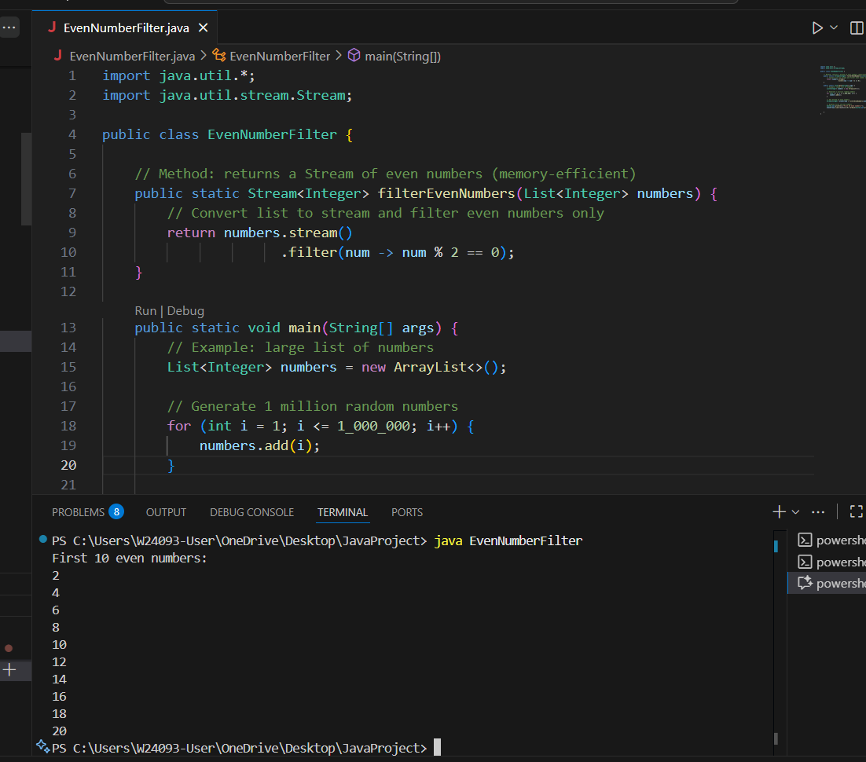

A: Parallel processing, but still stores all results in memory.

B: Sequential stream, same memory problem.

C: Uses lazy stream processing — no large list stored.

D: LinkedList still stores all elements — inefficient.

Q5.
Answer is C.

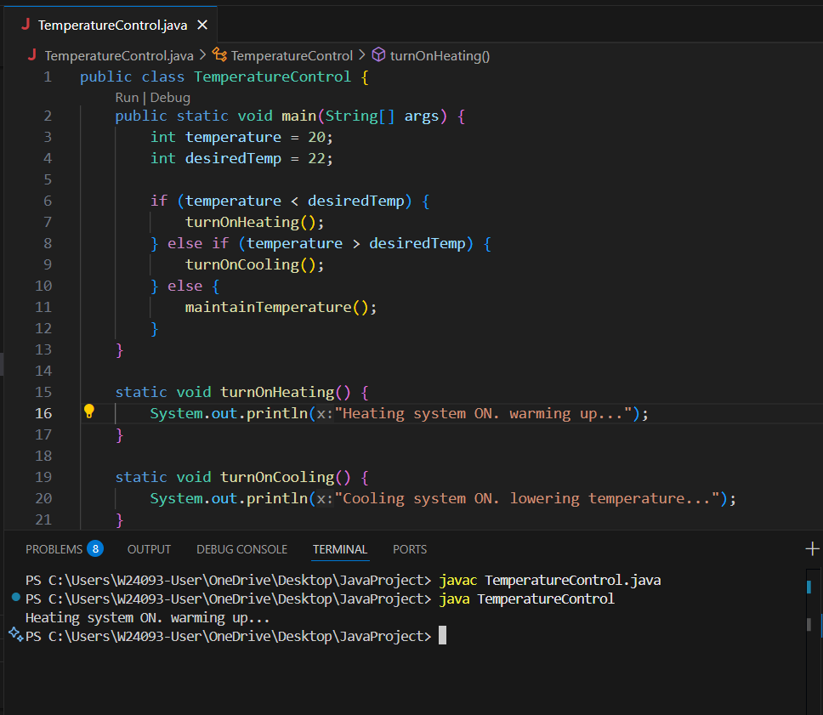

A: No handling for equal temperature. It might turn on cooling even when already at 22°C.

B: Could cause infinite loop if the temperature never exactly matches (like 21.9°C). Not efficient for control systems.

C: Safest and most realistic for automated systems.

D: Invalid syntax in Java; can’t use inequalities inside a switch statement.

Q6.
Answer is C.

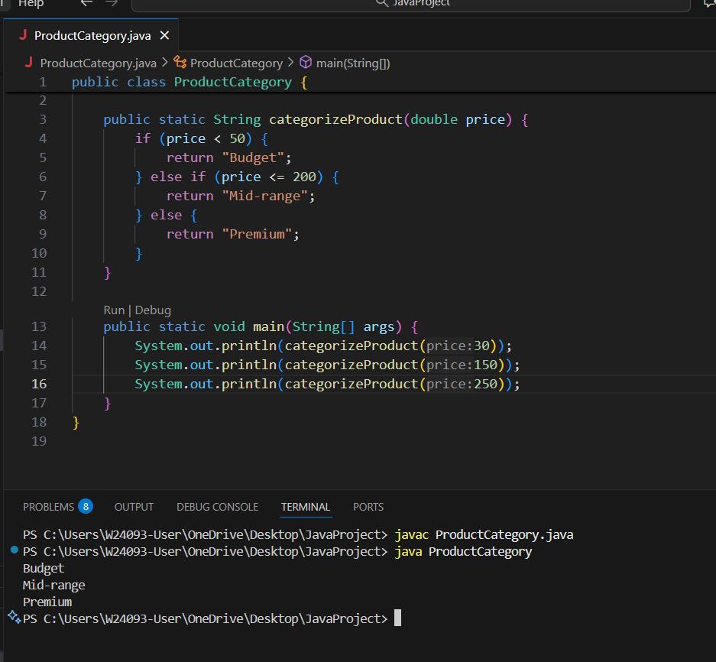

A: must used else-if .

B: A switch cannot easily handle ranges like < 50 or > 200.

C: Correct and efficient.

D: Infinite loop, poor structure.

Q7.
Answer is C.

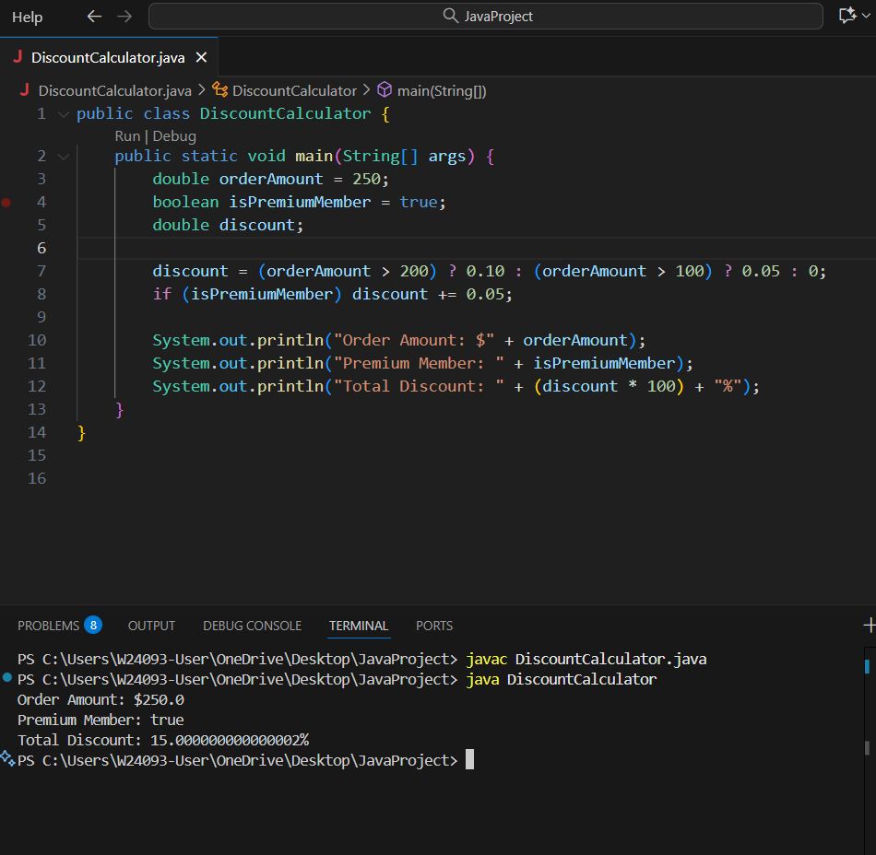

A: Still valid, just not as clean as option C.

B: Works, but redundant checks make it less efficient and less clear.

C: correct and clean.

D: That’s mathematically incorrect.

Q8.
Answer is D.

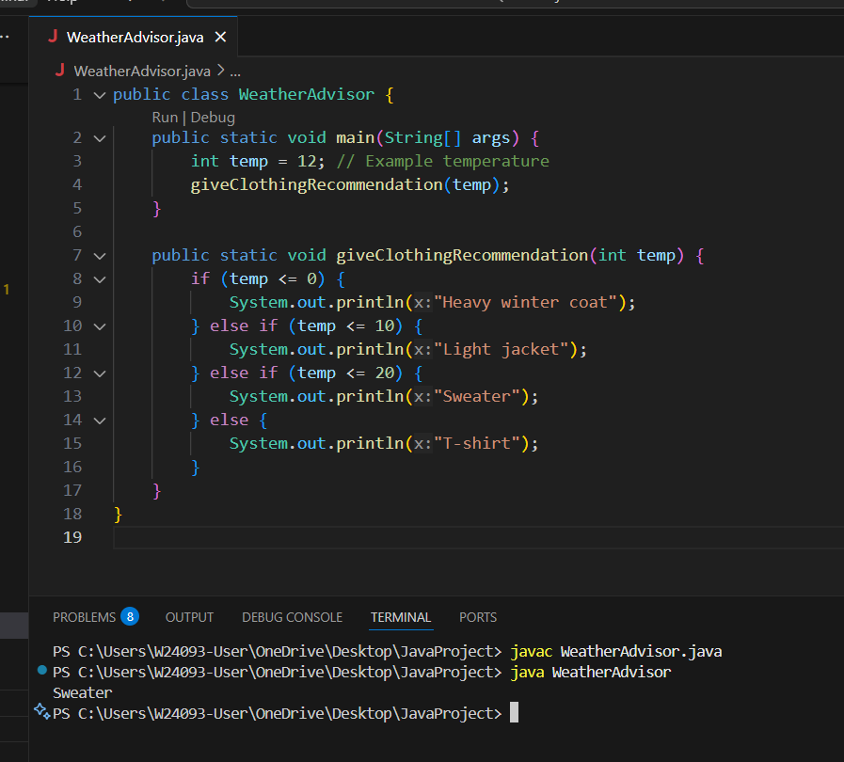

A: Incorrect boundary handling.

B: Not valid code at all.

C: Completely invalid in Java.

D: Correct.

